PhotoShop Lesson: Add Pop to your Photos
Objective: In this lesson you will apply special effects to photos by de-emphasizing the background in different ways.
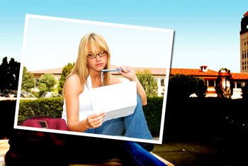
- Open or paste a picture.
- Use the Rectangular Marquee to select the portion to be framed.
- Choose SELECT/Transform Selection.
Then point to a corner and tilt it about 5 - 8˚
- Click Apply or press ENTER 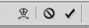
- Press Ctrl-J to duplicate the layer.
Now look on your Layers palette and notice that the top layer is a cut-out.
- To add a stroke and drop shadow to the top layer, choose LAYER/Layer Style/Stroke.
- Change Color to white
- Change Position to Inside
- Change Stroke to about 9pt
- Then add a Drop Shadow (About 130˚ places the shadow on the right/bottom.)
- To add the darkened effect, click on the bottom layer.
- Choose IMAGE/Adjustment/Levels. Slide the dark level over to about 160
- Try different effects:
  - Undo the Levels effect. Then choose IMAGE/Adjustment/Desaturate (you now have a grayscale background)
  - Undo the Desaturation effect. Then choose FILTER/Radial Blur. Set to 36 and Zoom.

