Photoshop Lesson 2

Blending Images

Clouds:  - Copy the flag  - Then paste it into a new Photoshop file.  - Change foreground to blue; background to white.  - Use Magic Wand to select the sky.  - Click FILTER/Render/Clouds.  - Click SELECT/Deselect. | 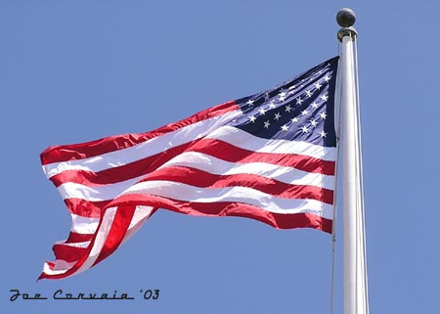

Finishing touches:  - Find picture of an eagle or Statue of Liberty from the clipart gallery or from the web.� The lighter the background, the better.  - Copy and paste onto the flag.  - If too large, click EDIT/Free Transform to resize the layer.  - Use the Lasso Tool to select part of it.  - Click SELECT/Feather. Type in a number between 2 and 30.  - Click SELECT/Inverse to select the part that you don't want. Press [DELETE] key.  - Reduce the Opacity so that they will blend better (Layers palette)  - If necessary, use the Move tool to reposition the eagle.  - It is also probably necessary to resize it. (EDIT/Free Transform) | 